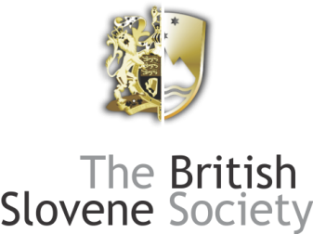

*

APPLICATION FORM FOR ANNUAL DINNER

8 February 2014

Please print out, fill in and send together with your cheque or confirmation of payment to:

Gorazd Kert, Flat 14, 156 Queenstown Road, SW8 3QE London or
e-mail to: treasurer@britishslovenesociety.org

Full name (Mr/Mrs/Ms)………………………………………………
Address…………………………………………………………………………………….
………………………………………………………….……….………………………………………………………………………………………………………………………..
………………………………………………………….……….…………………………
Post Code……………………………………..
Tel. No. ……………………………………….
E-mail address: ………………………………………………………
No. of persons…………
Names of other guests in the party
………………………………………………………….……….………………………………………………………………………………………………………………………..
………………………………………………………….……….………………………………………………………………………………………………………………………..
Vegetarian meals required……………….
Amount paid: £………
Please make cheques payable for the full amount to The British-Slovene Society or send direct to the Society’s bank account: The British-Slovene Society, Sort code: 40-01-06, Account: 71358332. Please put your name and “Dinner” in the reference.

